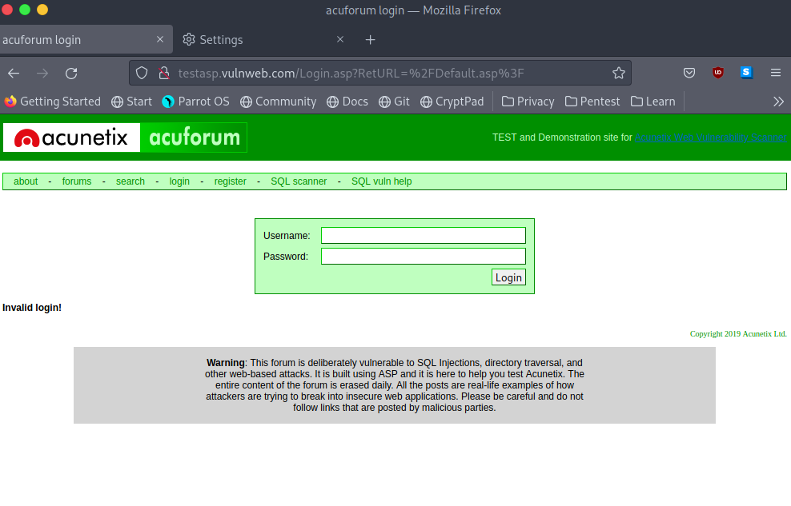

This is the website I attempted to crack, the valid login credentials are test and test.

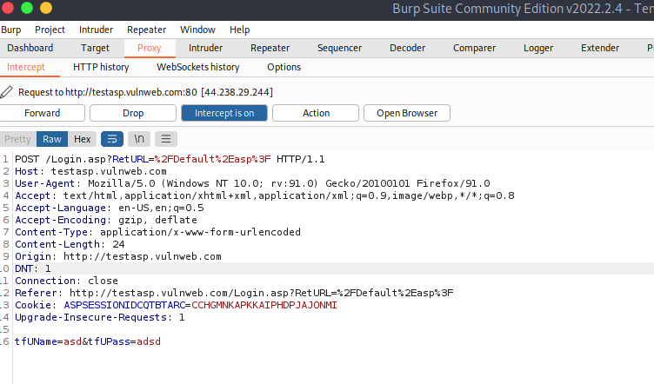

This is the captured information from burpsuite with incorrect credentials.

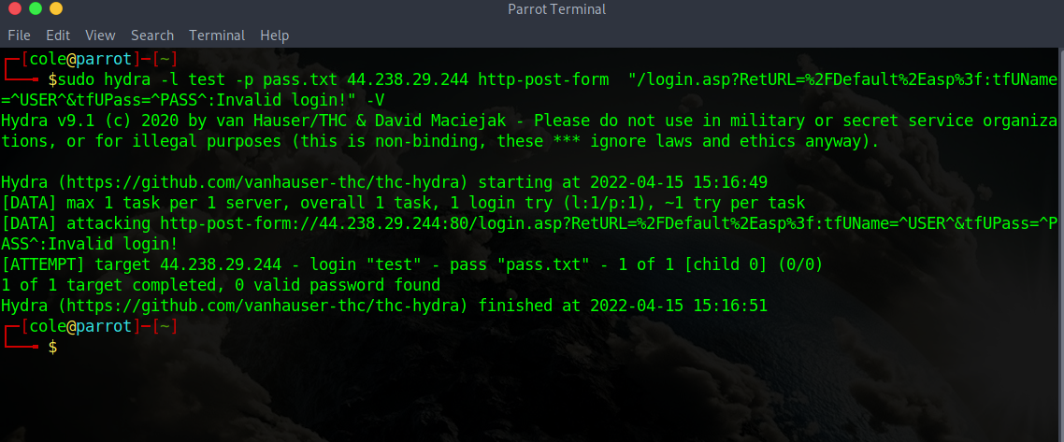

No matter what I tried, I couldn’t get it to crack the password, even though pass.txt had the right password in it.

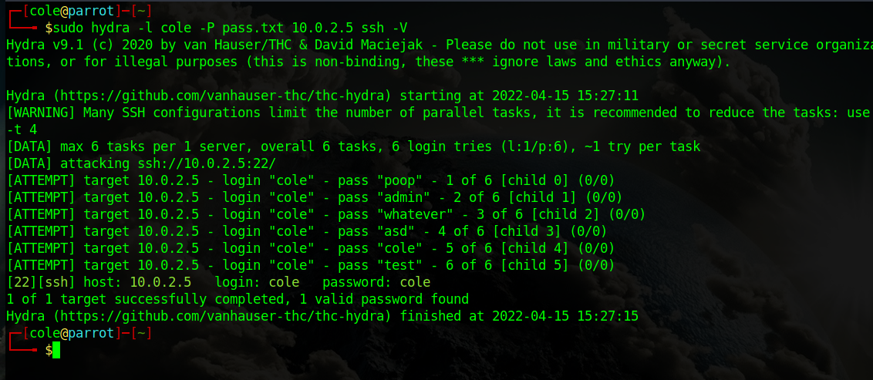

So I instead cracked a vm of mine over an ssh server.